# Git revert commit before pushing

Git reset HEAD^

# Git revert commit after pushing and merged to master

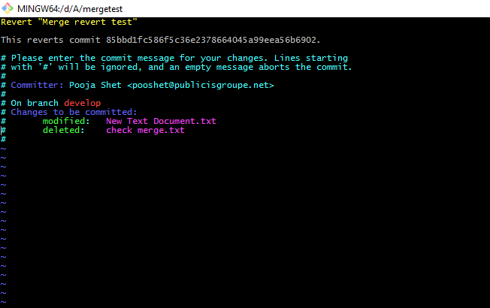

Esc :q!

pooshet@INMUBFLP1568 MINGW64 /d/A/mergetest (master)

$ git checkout develop

Switched to branch 'develop'

pooshet@INMUBFLP1568 MINGW64 /d/A/mergetest (develop)

$ git status

On branch develop

Changes not staged for commit:

(use "git add <file>..." to update what will be committed)

(use "git checkout -- <file>..." to discard changes in working directory)

modified: New Text Document.txt

Untracked files:

(use "git add <file>..." to include in what will be committed)

check merge.txt

no changes added to commit (use "git add" and/or "git commit -a")

pooshet@INMUBFLP1568 MINGW64 /d/A/mergetest (develop)

$ git add .

pooshet@INMUBFLP1568 MINGW64 /d/A/mergetest (develop)

$ git commit -m "Merge revert test"

[develop 85bbd1f] Merge revert test

Committer: Pooja Shet <pooshet@publicisgroupe.net>

Your name and email address were configured automatically based

on your username and hostname. Please check that they are accurate.

You can suppress this message by setting them explicitly. Run the

following command and follow the instructions in your editor to edit

your configuration file:

git config --global --edit

After doing this, you may fix the identity used for this commit with:

git commit --amend --reset-author

2 files changed, 2 insertions(+)

create mode 100644 check merge.txt

pooshet@INMUBFLP1568 MINGW64 /d/A/mergetest (develop)

$ git push origin develop

Counting objects: 3, done.

Delta compression using up to 4 threads.

Compressing objects: 100% (2/2), done.

Writing objects: 100% (3/3), 294 bytes | 0 bytes/s, done.

Total 3 (delta 0), reused 0 (delta 0)

remote:

remote: To create a merge request for develop, visit:

remote: https://git.cloud.flip.me/pooja.shet/mergetest/merge_requests/new?merg e_request%5Bsource_branch%5D=develop

remote:

To https://git.cloud.flip.me/pooja.shet/mergetest.git

472e06c..85bbd1f develop -> develop

pooshet@INMUBFLP1568 MINGW64 /d/A/mergetest (develop)

$ git checkout master

Your branch is up-to-date with 'origin/master'.

Switched to branch 'master'

pooshet@INMUBFLP1568 MINGW64 /d/A/mergetest (master)

$ git merge develop

Updating 472e06c..85bbd1f

Fast-forward

New Text Document.txt | 1 +

check merge.txt | 1 +

2 files changed, 2 insertions(+)

create mode 100644 check merge.txt

pooshet@INMUBFLP1568 MINGW64 /d/A/mergetest (master)

$ git push origin master

Total 0 (delta 0), reused 0 (delta 0)

To https://git.cloud.flip.me/pooja.shet/mergetest.git

472e06c..85bbd1f master -> master

pooshet@INMUBFLP1568 MINGW64 /d/A/mergetest (master)

$ git checkout develop

Switched to branch 'develop'

pooshet@INMUBFLP1568 MINGW64 /d/A/mergetest (develop)

$ git log

commit 85bbd1fc586f5c36e2378664045a99eea56b6902

Author: Pooja Shet <pooshet@publicisgroupe.net>

Date: Fri Aug 18 14:04:07 2017 +0530

Merge revert test

commit 472e06cd9e94665d8be23820018d8d40d60cb8c7

Author: Pooja Shet <pooshet@publicisgroupe.net>

Date: Fri Aug 18 13:38:34 2017 +0530

Revert "test 1"

This reverts commit f20898923d863b3766b6fc50a6a8f82985c228fb.

commit f20898923d863b3766b6fc50a6a8f82985c228fb

Author: Pooja Shet <pooshet@publicisgroupe.net>

Date: Fri Aug 18 13:15:32 2017 +0530

test 1

commit 702bb6c5a24437c8e5166bc8e31a06a1b21c2551

Author: Pooja Shet <pooshet@publicisgroupe.net>

Date: Fri Aug 18 13:12:51 2017 +0530

:...skipping...

commit 85bbd1fc586f5c36e2378664045a99eea56b6902

Author: Pooja Shet <pooshet@publicisgroupe.net>

Date: Fri Aug 18 14:04:07 2017 +0530

Merge revert test

commit 472e06cd9e94665d8be23820018d8d40d60cb8c7

Author: Pooja Shet <pooshet@publicisgroupe.net>

Date: Fri Aug 18 13:38:34 2017 +0530

Revert "test 1"

This reverts commit f20898923d863b3766b6fc50a6a8f82985c228fb.

commit f20898923d863b3766b6fc50a6a8f82985c228fb

Author: Pooja Shet <pooshet@publicisgroupe.net>

Date: Fri Aug 18 13:15:32 2017 +0530

test 1

commit 702bb6c5a24437c8e5166bc8e31a06a1b21c2551

Author: Pooja Shet <pooshet@publicisgroupe.net>

Date: Fri Aug 18 13:12:51 2017 +0530

first commit

**~**

**~**

**~**

**~**

**~**

**~**

**~**

**~**

**~**

**~**

**~**

**~**

**~**

**~**

**~**

**~**

**~**

**~**

**~**

**~**

**~**

**~**

**~**

**~**

**~**

**~**

**~**

**~**

**~**

**~**

**~**

**~**

pooshet@INMUBFLP1568 MINGW64 /d/A/mergetest (develop)

$ git revert 85bbd1fc586f5c36e2378664045a99eea56b6902

[develop f75cdd3] Revert "Merge revert test"

Committer: Pooja Shet <pooshet@publicisgroupe.net>

Your name and email address were configured automatically based

on your username and hostname. Please check that they are accurate.

You can suppress this message by setting them explicitly. Run the

following command and follow the instructions in your editor to edit

your configuration file:

git config --global --edit

After doing this, you may fix the identity used for this commit with:

git commit --amend --reset-author

2 files changed, 2 deletions(-)

delete mode 100644 check merge.txt

pooshet@INMUBFLP1568 MINGW64 /d/A/mergetest (develop)

$ git push origin develop

Counting objects: 3, done.

Delta compression using up to 4 threads.

Compressing objects: 100% (1/1), done.

Writing objects: 100% (3/3), 290 bytes | 0 bytes/s, done.

Total 3 (delta 0), reused 0 (delta 0)

remote:

remote: To create a merge request for develop, visit:

remote: https://git.cloud.flip.me/pooja.shet/mergetest/merge_requests/new?merge_request%5Bsource_branch%5D=develop

remote:

To https://git.cloud.flip.me/pooja.shet/mergetest.git

85bbd1f..f75cdd3 develop -> develop

pooshet@INMUBFLP1568 MINGW64 /d/A/mergetest (develop)

$ git checkout master

Your branch is up-to-date with 'origin/master'.

Switched to branch 'master'

pooshet@INMUBFLP1568 MINGW64 /d/A/mergetest (master)

$ git merge develop

Updating 85bbd1f..f75cdd3

Fast-forward

New Text Document.txt | 1 -

check merge.txt | 1 -

2 files changed, 2 deletions(-)

delete mode 100644 check merge.txt

pooshet@INMUBFLP1568 MINGW64 /d/A/mergetest (master)

$ git push origin master

Total 0 (delta 0), reused 0 (delta 0)

To https://git.cloud.flip.me/pooja.shet/mergetest.git

85bbd1f..f75cdd3 master -> master